FPGA BASED SYSTEM DESIGN
QUIZ NO 02
NAME: ROLL NO:
SEMMESTER VIII DATE: 13TH MAR, 2014

- Casex does support? . True / False (1)
- Case does support? . True / False (1)
- What are the differences between VERILOG and VHDL.(3)

- Declared modules cannot be instantiated. True / False (1)
- INOUT is a reserve word. True / False (1)
- Initial command is terminated with a reserve key word end. True / False (1)
- What is the length of integers? (1)

- Integers are recommended for synthesis. True / False (1)
- Sequence of non-blocking assignments executes sequentially. True / False (1)
- Find the error in the following code and correct the code as well. (9)
- @module mux2to1 (y,a,b,sel);
output y;
inputa,b :
reg y [n-1:0]:
inputsel;
always @ (a | b or sel)
if(sel)
y = a;
else,
y = b;
endmodule

- module sum@ur code(sum,datain,clk)”
output sum?
Input data_in, clk;
reg I;
always @ (pos_edgeclk)
for (I = 0, I < 5; I = i+1)
sum = sum + datain[i];
endmodule

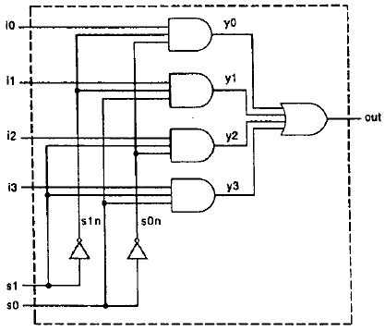

Q1. Draw the schematic of complementary Nand Gate.
Q2. Draw the schematic of complementary of Nor Gate.

