**Objective**

1. Familiarize with the construction and operation of Light Dependent Resistors (LDR) or Photo Resistor.
2. Use Light Dependent Resistor (LDR) as a Photo Voltaic Detector.
3. Finding Out put Voltage and LDR Current relationship.

**Theory**

Photoconductive light sensor does not produce electricity but simply changes its physical properties when subjected to light energy. The most common type of photoconductive device is the Photo resistor which changes its electrical resistance in response to changes in the light intensity. Photo resistor are Semiconductor devices that use light energy to control the flow of electrons, and hence the current flowing through them. The commonly used Photoconductive Cell is called the Light Dependent Resistor or LDR



As its name implies, the Light Dependent Resistor (LDR) is made from a piece of exposed semiconductor material such as cadmium sulphide that changes its electrical resistance from several thousand Ohms in the dark to only a few hundred Ohms when light falls upon it by creating hole electron pairs in the material.

**Apparatus**

• LED (Red, Green, Yellow, IR LED)

• Photo Diode (Rx)

• Power Supply (10V variable & 10Vor 5V fixed)

• Digital Multimeter (DMM)

• Resisters (1kΩ, 47kΩ)

• LDR

**Circuit Diagram**

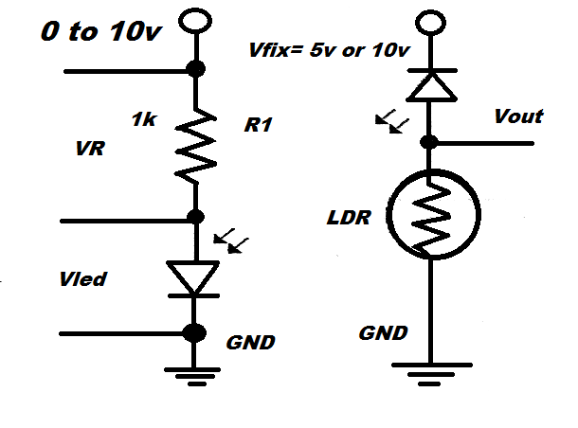

**Observation**

|  |  |  |  |  |
| --- | --- | --- | --- | --- |
| **Red** | | | | |
| **S. No.** | **V Applied**  **(V)** | **VLED**  **(V)** | **VOUT**  **(V)** | **IO (ILDR)**  **(mA)** |
|  |  |  |  |  |
|  |  |  |  |  |
|  |  |  |  |  |
|  |  |  |  |  |
|  |  |  |  |  |
|  | | | | |

|  |  |  |  |  |
| --- | --- | --- | --- | --- |
| **Green** | | | | |
| **S. No.** | **V Applied**  **(V)** | **VLED**  **(V)** | **VOUT**  **(V)** | **IO (ILDR)**  **(mA)** |
|  |  |  |  |  |
|  |  |  |  |  |
|  |  |  |  |  |
|  |  |  |  |  |
|  |  |  |  |  |
|  | | | | |

|  |  |  |  |  |
| --- | --- | --- | --- | --- |
| **Yellow** | | | | |
| **S. No.** | **V Applied**  **(V)** | **VLED**  **(V)** | **VOUT**  **(V)** | **IO (ILDR)**  **(mA)** |
|  |  |  |  |  |
|  |  |  |  |  |
|  |  |  |  |  |
|  |  |  |  |  |
|  |  |  |  |  |
|  | | | | |

|  |  |  |  |  |
| --- | --- | --- | --- | --- |
| **I.R** | | | | |
| **S. No.** | **V Applied**  **(V)** | **VLED**  **(V)** | **VOUT**  **(V)** | **IO (ILDR)**  **(mA)** |
|  |  |  |  |  |
|  |  |  |  |  |
|  |  |  |  |  |
|  |  |  |  |  |
|  |  |  |  |  |
|  | | | | |

**Graph**



**RED GREEN**



**YELLOW** **I.R**

**Result**

From the graph the relationship between Output voltage &Output current is observed.

        • It is -------------------------- (Linear/ Nonlinear).