NAME: ROLL NO.
FPGA BASED SYSTEM DESIGN
QUIZ NO. 02
LABEL THE FPGA GENERIC ARCHITECTURE.(6)
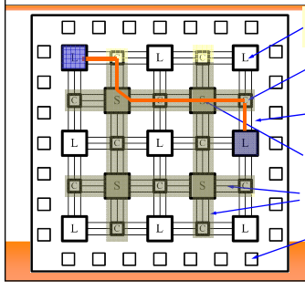
2. The following diagrams are used for the different logical symbols, specify them.(4)
