Example 1

Find an interpolation formula for ƒ(x) = tan(x) given this set of known values:
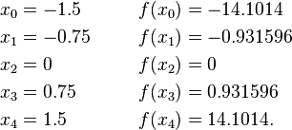
The Lagrange basis polynomials are:
Thus the interpolating polynomial then is
